Proposed Solution

Introduction
The Metro Ticket Generating System is a digital ticket booking application developed on the ServiceNow platform to modernize and automate the metro ticketing process. The solution replaces manual ticket booking with an online system that enables passengers to reserve metro tickets through the Service Portal. By integrating automation tools such as Service Catalog, Flow Designer, Catalog Client Scripts, UI Policies, and custom database tables, the application provides a secure, efficient, and scalable ticketing solution.

Solution Overview
The proposed system provides a centralized platform where passengers can book metro tickets without visiting a physical ticket counter. Users access the Book A Metro Ticket catalog item through the Service Portal and enter journey details, including the source station, destination station, passenger type, journey type, and number of passengers. The system validates the entered information and automatically calculates the ticket fare.
Once the booking is confirmed, Flow Designer processes the request and stores all booking details in the custom Metro Database table. A QR code is then generated, which serves as the passenger’s digital ticket. This automated workflow minimizes manual intervention while ensuring secure storage of ticket information.

System Components
The proposed solution is composed of several integrated ServiceNow components. The Service Portal provides the user interface for ticket booking, while the Service Catalog hosts the booking form. Catalog Variables capture passenger information, and Catalog Client Scripts perform fare calculation and field validation. UI Policies dynamically display or hide fields based on user selections, improving usability.
Flow Designer automates the ticket booking process by retrieving catalog variables, creating records in the Metro Database, and coordinating ticket generation. The Metro Database stores all booking records, while Access Control Lists (ACLs) restrict unauthorized access to sensitive information. Finally, QR Code Generation provides passengers with a secure and paperless travel ticket.
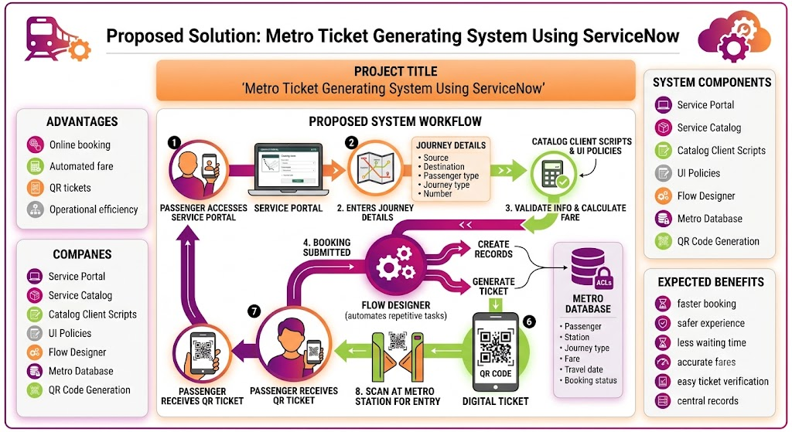

Proposed System Workflow
The passenger accesses the Service Portal and opens the metro ticket booking form. After entering journey details, the system validates the information and calculates the fare automatically. When the booking is submitted, Flow Designer retrieves the submitted variables, stores the booking information in the Metro Database, and generates a QR code. The passenger receives the QR ticket, which can be scanned at the metro station for entry. Throughout the process, Access Control Lists protect sensitive booking information from unauthorized access.

